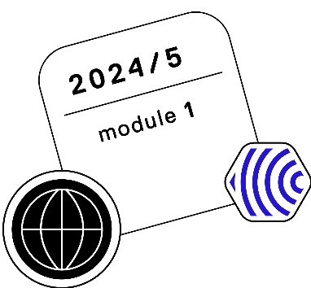

Market Access Landscape and Policy

14th – 18th of October 2024

|  |  |  |  |  |
| --- | --- | --- | --- | --- |
| **Monday, 14th** | **Tuesday, 15th** | **Wednesday, 16th** | **Thursday, 17th** | **Friday, 18th** |
|  | 09:00 – 10:00 | 09:00 – 10:00 | 09:00 – 10:00 | 09:00 – 10:00 |
| Market Access in Spain  **Oriol Sola-Morales** | **Panel Discussion**  EU5 + Sweden/Scandinavia | Market Access in France  **Mira Pavlovic** | **Panel Discussion**  Central Europe/Asia/  Latin America/MENA |
| Break | Break | Break | Break |
| 10:15 – 11:15 | 10:15 – 11:15 | 10:15 – 11:15 | 10:15 – 12: 45 |
| Market Access in Poland  **Krzysztof Kloc** | Market Access in MENA  **Yesil Atakan** | Market Access in Central Europe  **David Danko** | Workshop session in Breakout rooms |
| Break | Break | Break |
| 11:30 – 12:30 | 11:30 – 12:30 | 11:30 – 12:30 |
| Market Access in Italy  **Claudio Jommi** | **OPEN SLOT** | Market Access in Tunisia  **Mouna Jameleddine** |
| Break | Break | Break | Break |
| 13:30 – 14:30 | 13:30 – 14:30 | 13:30 – 14:30 | 13:30 – 14:30 | 13:00 – 14:00 |
| Introduction Part I  **Mondher Toumi** | Market Access in Germany  **Frank-Ulrich** | Market Access in Canada  **Philippe Larame** | Market Access in Turkey  **Kagan Atikeler** | Conclusion  **Mondher Toumi** |
| Break | Break | Break | Break |  |
| 14:45 – 15:45 | 14:45 – 15:45 | 14:45 – 15:45 | 14:45 – 15:45 |
| Introduction Part II  **Mondher Toumi** | Market Access in UK  **Keith Tolley** | Market Access in US  **JAMES CHAMBERTS** | Market Access in Japan  **Ataru Igarashi** |
| Break | Break | Break | Break |
| 16:00 – 17:00 | 16:00 – 17:00 | 16:00 – 17:00 | 16:00 – 17:00 |
| Introduction Part III  **Mondher Toumi** | Market Access in Sweden & Scandinavia  **Ulf Person** | **Panel Discussion**  US + Canada | Market Access in Brazil and Latin America  **Beatris Kamper** |

*The schedule may be subject to minor changes